EXPERIMENT 2
DDL Commands with Constraints – PRIMARY, FOREIGN KEY, UNIQUE, CHECK
AIM:
To add the constraints like primary key, foreign key, unique key and check using DDL commands.
DESCRIPTION:
PRIMARY KEY:
The PRIMARY KEY constraint uniquely identifies each record in a database table.
Primary keys must contain UNIQUE values and cannot contain NULL values.
FOREIGN KEY:
A FOREIGN KEY is used to link two tables together. It refers to the PRIMARY KEY of another table.
UNIQUE Constraint:
The UNIQUE constraint ensures that all values in a column are different.
CHECK Constraint:
The CHECK constraint is used to limit the values that can be entered into a column.
PROCEDURE
- Open MySQL Workbench and connect to the MySQL server.
- Select the bank database using the USE command.
- Create the required tables: BANKRECORDS, ACCOUNT, BRANCH, and TRANSACTION.
- Add the PRIMARY KEY constraints to the required columns using ALTER TABLE.
- Add the CHECK constraints to restrict the allowed values.
- Add the UNIQUE constraint to the NAME column of the BANKRECORDS table.
- Add the FOREIGN KEY constraint to connect TRANSACTION.AccountNo with ACCOUNT.AccountNo.
- Use the DESC command to verify the table structures and constraints.
- Observe and record the outputs displayed in MySQL Workbench.

SYNTAX
PRIMARY:
SQL
ALTER TABLE table_name
ADD PRIMARY KEY(primary_key_column);
FOREIGN KEY:
SQL
ALTER TABLE table_name
ADD CONSTRAINT constraint_name
FOREIGN KEY (foreign_key_column)
REFERENCES parent_table(parent_column);
UNIQUE:
SQL
ALTER TABLE table_name
ADD UNIQUE(column_name);
CHECK:
SQL
ALTER TABLE table_name
ADD CHECK(condition);

QUESTIONS
1) Alter the table BANKRECORDS with the following structure.
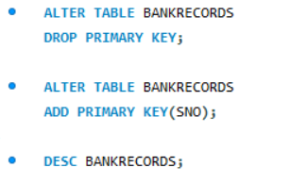
OUTPUT:
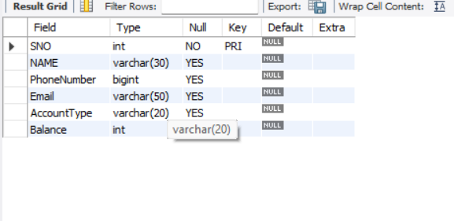
2) Alter the table ACCOUNT with the following structure

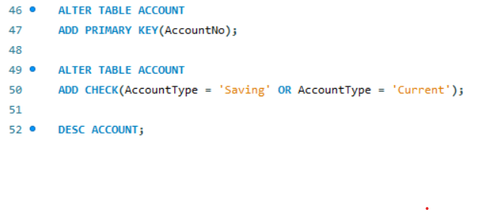
OUTPUT:
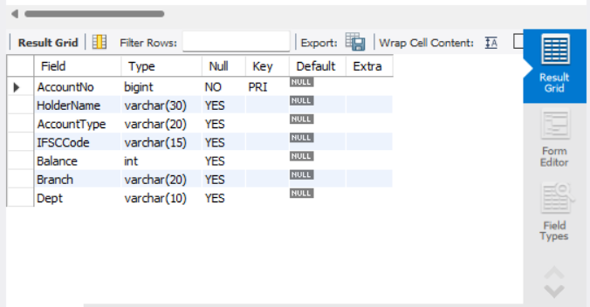

3) Alter the table BRANCH with the following structure
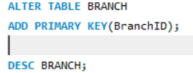
OUTPUT:
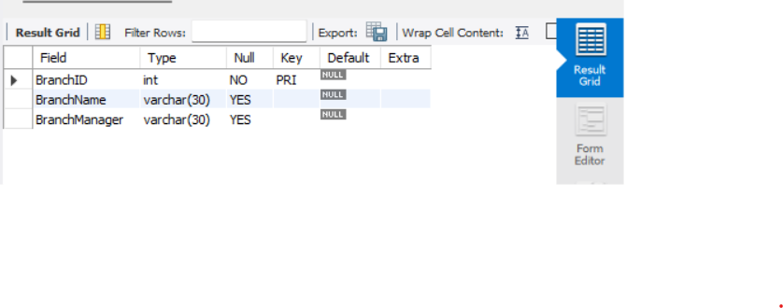
4) Alter the table TRANSACTION with the following structure
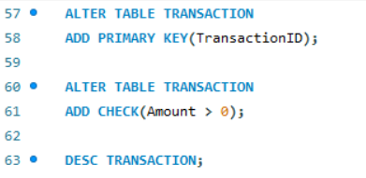
OUTPUT:
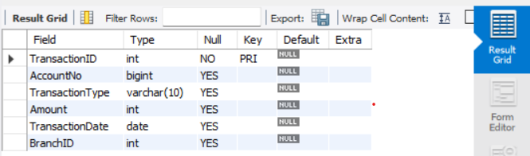
5) Alter the table BANKRECORDS with the following structure


OUTPUT:
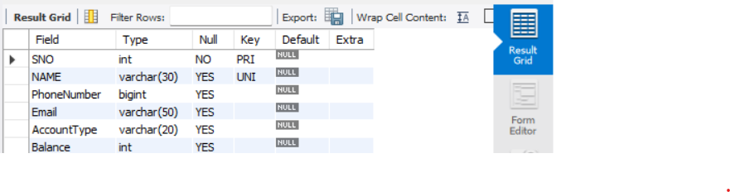
6) After the ACCOUNT & TRANSACTION tables are successfully created, test if you can add a constraint FOREIGN KEY to the AccountNo of this table.
Parent table: ACCOUNT
Parent key: AccountNo
Child table: TRANSACTION
Foreign key: AccountNo
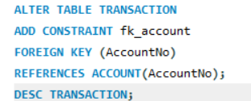
OUTPUT:
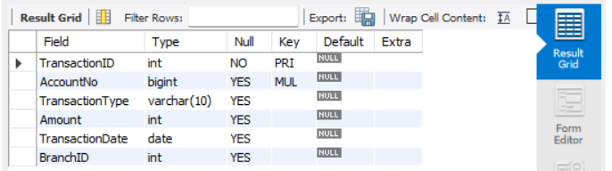
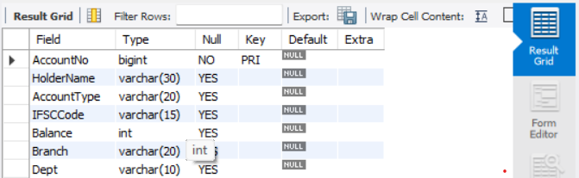
RESULT:
Thus, the DDL commands with PRIMARY KEY, FOREIGN KEY, UNIQUE KEY and CHECK constraints were successfully implemented and verified in the BANKRECORDS, ACCOUNT, BRANCH and TRANSACTION tables.

